
Name : PRAVEENSANKAR M
Register Number :CS18M1008
Course : M.Tech
Semester : I
Subject : Advanced Programming Laboratory (CS611)

Euler , sum of digits

AIM
To implement euler’s number , sum of digits of a number in python.

PROGRAM
euler.py

def fact(n):
res=1
for i in range(1,n+1):
res=res*i
return res
def euler(n):
res=1
for i in range(1,n+1):
res=res+(1/fact(i))
return res
while True:
n=int(input("enter n :<-1 to break> : "))
if n==-1:
break
sum=euler(n)
print(sum)

sum_of_digits.py

while True:
n = int(input("please enter the digit <-1 to break> : "))
if n==-1:
break
res=0
temp=n
while temp!=0:
res=res+temp%10
temp=temp//10
res1=0
while res!=0:
res1=res1+res%10
res=res//10
print("result is :",res1)

OUTPUT

euler.py

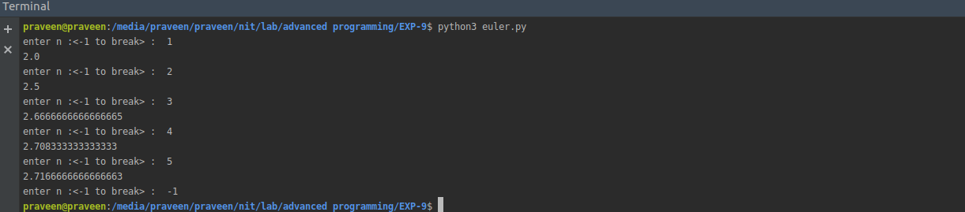
sum_of_digits.py
